Azure Key Vault.

* <https://docs.microsoft.com/en-us/azure/key-vault/general/basic-concepts>
* When we choose an option of encrypting with out own keys we can use Azure key vault to store our keys and use them at different resource level.
* 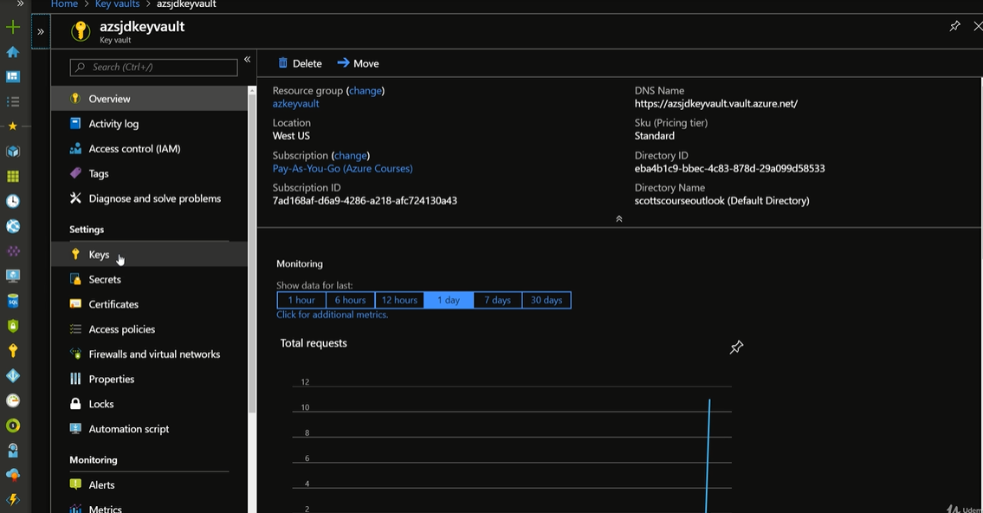
* Secrets can used by the links in a web application.
* Certificates are used for signing in.
* Enable disbale keys, secrets and certificates according to your convenience.
* https://github.com/Azure-Samples/key-vault-dotnet-manage-key-vaults